V5 18/5/2023
St Barnabas’ Hall
Hire Information Pack

GENERAL INFORMATION ABOUT ST BARNABAS’ HALL
Reading Gateway church has three sites: St Agnes, St Barnabas and St Paul. St Barnabas’ Hall is situated on Elm Road, in the Shinfield Road area of South Reading. It is easily accessible by car with car parking facilities on site and is on the number 8 bus route.
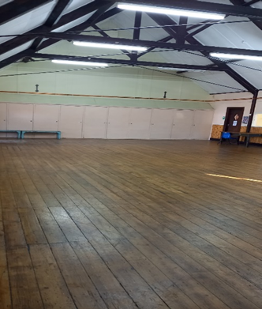
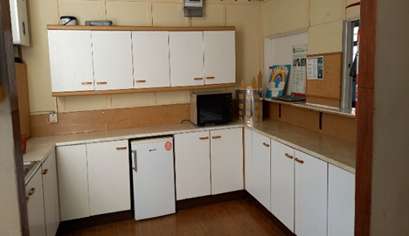
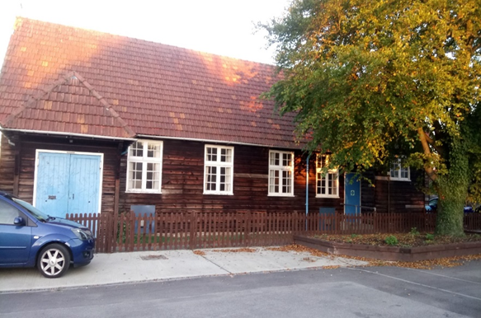
The hall is available for hire to individuals, organisations, and local groups. There is a large spacious main hall, maximum capacity 80 people, with a kitchen off to the side. The building is accessible to wheelchair users with a small, enclosed garden at the rear of the building, ideal for children’s activities.

St Barnabas’ Hall Hire Charges
All Contracts
No contract is confirmed unless a written contract has been signed (in several places) by the hirer, and a copy has been returned to the hirer, signed by the Parish Administrator, Treasurer, Rector or PCC Secretary to confirm receipt of the (initial) payment.

One-off bookings
Hire charge and deposit must be received by BACS transfer no later than four weeks before the event.
Deposit: £100. This will be returned up to 2 weeks after the event, providing no damages or costs have been incurred.
Hourly rate: £25 (Registered charities: £20)
Bookings only accepted in half-hourly increments
Use of Kitchen:
Kettle, hot water boiler, cutlery and crockery: included in hire charge
Cookers, microwave, dishwasher, freezer etc (see equipment table below): £25/hr
Minimum booking on a Weekend: 4hrs
Set Up and Clear Up times: All bookings must include an appropriate allowance for set up and clear up times (minimum ½ hour for each).

Short Term Repeat bookings
Where a number of bookings are covered by a single contract, for example events during a single term or a single school holiday, these are treated as ‘short term repeat bookings’. Bookings required to span several discreet periods of time (e.g. multiple terms or multiple holidays) will be subject to separate contracts for each discreet period.
Where the contract covers a period of less than eight weeks, the deposit and the full hire charge for the whole contract must be received by BACS transfer no later than four weeks before the first booking.
Where the contract covers a period equal to or exceeding eight weeks, the deposit and hire charge for the first four weeks of bookings must be received by BACS transfer no later than four weeks before the first booking. Remaining hire charges are payable in four-weekly instalments (by BACS transfer), each at least four weeks before the first of the next group of four-week bookings.
Deposit: £100. This will be returned up to 2 weeks after the final booking, providing no damages or costs have been incurred. Reading Gateway Church reserves the right to keep the deposit and terminate the contract with immediate effect, if the hall is left in an unacceptable state, or the terms of the contract are not adhered to.
Hourly rate: £25 (Registered charities: £20)
Bookings only accepted in half-hourly increments
Use of Kitchen:
Kettle, hot water boiler, cutlery and crockery: included in hire charge
Cookers, microwave, dishwasher, freezer etc (see equipment table below): £25/hr
Minimum booking on a Saturday: 4hrs
Set Up and Clear Up times: All bookings must include an appropriate allowance for set up and clear up times. The default is a minimum ½ hour for each, but this may be varied by agreement with the Parish.

Long Term Hire
Long term hire is a minimum of a one-year contract, where the hire fee is paid in equal monthly instalments, one month in advance, regardless of whether all the hours booked in a given month are actually used. In recognition of the commitment involved, Long Term hires attract a discount (see below).
Hire charge for deposit and first calendar month of bookings must be received by BACS transfer no later than one calendar month before the contract start date. Subsequent monthly hire charges must be received no later than one calendar month in advance.
Deposit: £100. This will be returned up to 2 weeks after the contract end, providing no damages or costs have been incurred. Reading Gateway church reserves the right to keep the deposit and terminate the contract with immediate effect, if the hall is left in an unacceptable state, or the terms of the contract are not adhered to. Otherwise, the deposit will be returned up to two weeks after the contract end, providing no damages or costs have been incurred.
Hourly rate: £25 (Registered charities: £20)
Bookings only accepted in half-hourly increments
Use of Kitchen:
Kettle, hot water boiler, cutlery and crockery: included in hire charge
Cookers, microwave, dishwasher, freezer etc (see equipment table below): £25/hr
Minimum booking on a Saturday: 4hrs
Set Up and Clear Up times: All bookings must include an appropriate allowance for set up and clear up times. The default is a minimum ½ hour for each, but this may be varied by agreement with the Parish.
Discount:
Hourly rate set as follows:
- £16/h for average weekly hours >10;
- £20/h for average weekly hours between 2 and 10, or hirer is a charity;
- No discount if neither of the former applies, ie £25/h

Equipment available at St Barnabas
Equipment available for use in the hall:
Type of Equipment | Total Available
Trestle Tables | 15
Stacking Chairs | 50
Smaller Tables | 8
Children’s Chairs | 12

Equipment available for use in the Kitchen:
Type of Equipment | Total Available | Hall rate or Kitchen rate
Fridge | 1 | Hall rate
Kettle | 2 | Hall rate
Urn | 1 | Hall rate
Crockery | Limited | Hall rate
Cutlery | Limited | Hall rate
Cooker | 1 | Kitchen rate
Freezer | 1 | Kitchen rate
Microwave | 1 | Kitchen rate

First Aid Kit
A first aid kit is available in the kitchen.

NOTE: should an accident/incident occur during your time of hire, please record this in the book provided and report it to the Parish Administrator.

Terms and Conditions
General
- No hard footballs allowed on our premises (foam balls only)
- Children must be supervised by an adult at all times (inside the hall and outside areas)
- No smoking or gambling on Church premises.
- It is illegal to sell alcoholic drinks on the premises without the appropriate licence.
- Avoid excessive noise and loud music. No disco’s after 7:00pm
- Please respect neighbours and keep noise to a minimum, especially when leaving.
- Hirers must familiarise themselves with the location of Fire Exits. All extinguishers and escape routes must be kept clear of obstructions. Ensure you know where the Assembly Point is in case of fire.
- No animals without prior agreement, except dogs for the disabled.
- No bouncy castles unless agreed ahead of the event. The Parish is not insured for these: ensure your supplier of castle provides full liability insurance for this.
- No posters, notices, decorations etc. to be affixed to the interior or exterior of the premises without prior consent.
- The Hall must be vacated by the time stated on the contract, including clearing up afterwards.

Insurance

- Reading Gateway Church insurance covers church activities and those of affiliated groups. Reading Gateway Church insurance also covers one-off contracts, if there are no more than three bookings by a hirer in one year.
- All other groups are responsible for their own public liability insurance. Please make sure that you have adequate insurance to cover your event or regular activities.
- Your insurance needs to cover any loss or damage to the building and contents.
- Please note that you are primarily liable for any accident or injury arising out of your activities while using the premises.
- You will need to provide a copy of your insurance when making a booking.
- An Accident Book can be found in the kitchen: you must provide the details of any accident or incident that did or could cause injury, as soon as possible after it happens, but in any case, before you leave the building.

Equipment

- You may bring and use your own equipment subject to agreement with the Parish administrator. Reading Gateway Church PCC cannot accept responsibility for any damage, loss or theft of equipment brought into our premises.
- Do not touch any equipment left in the hall by another group: please report this to the person unlocking and locking the hall.

Use of Music & Videos

Playback of pre-recorded music and video clips (including radio and TV broadcasts) or the performance of live music is only permitted with the appropriate licence (please contact the parish office if you require advice). Further details are given below:

- Private parties (birthdays and family functions) are exempt.
- Weddings are covered by Reading Gateway Church’s licence, except where video recordings are made or when pre-recorded music is being played.
- Church-affiliated groups are covered by Reading Gateway Church’s licence for music and video.
- Business users must hold their own PPL and PRS licences. Special licences are required for fitness and dance classes.

Housekeeping

The hall and kitchen must be left clean and tidy (cleaning products are available). If further cleaning or clearing of the hall is necessary, or damage occurs, a further charge will be made to cover any costs incurred and will be deducted from the deposit.
Housekeeping checklist:
- Check toilets are clean, and all taps turned off.
- Kitchen area is left clean, and equipment put away.
- We do not supply or provide bin bags. All rubbish must be taken away at the end of your hire.
- Tables and chairs must be returned / stacked where found.
- Any damages must be reported to the person locking up or, where a key has been issued to the hirer, to the Parish Administrator as soon as possible after the event.
- Lighting must be switched off.
- Check all windows and doors are closed.
- If an alarm fob has been issued to the hirer, ensure building is alarmed on leaving.

Compliance with Reading Gateway Church Safeguarding Policy

You are required to ensure that children and vulnerable adults are always protected, by taking all reasonable steps to prevent any injury, loss, damage, or harm. We will require confirmation that you agree to comply with the Reading Gateway Church Safeguarding Policy. A copy is available to read at the venue, and online https://www.readinggateway.church/ . Our ‘Hire of Church Premises Safeguarding Provision Agreement’ must be signed and returned to us along with your booking form.

Use of Kitchen
Use of the cooker, microwave, urn and all other equipment may only be used by competent personnel: Reading Gateway accepts no liability for accidents resulting from improper use of kitchen equipment. Use of some kitchen equipment, eg the cooker, attracts a separate charge. These should not be used unless agreed and paid for in the contract.
Clearing up
We do not supply or provide bin bags. Please take all rubbish away with you at the end of your hire. Failure to comply may result in the loss of your deposit.
Public liability insurance
When hiring the hall for multiple events, the hirer must provide evidence of Public Liability Insurance at minimum indemnity of £5,000,000
Caretaking
The keyholder will open the venue at the stated time on your booking form and return at the closing time to supervise vacation of the venue.
Failure to adhere to the times stated will result in the loss of deposit.
Cancellations & Refunds
Notice of cancellation must be made at least 4 weeks before the first booking date for a full refund to be made. No refund will be made for cancellations within 4 weeks of the first booking.
Occasionally, it may be necessary for Reading Gateway church to cancel one or more sessions booked on a recurring contract. In such circumstances, the hirer will be given at least 4 weeks’ notice and a full refund of the relevant fees.
Early Termination of Contract
Early termination of recurring contracts (after first session has been held) requires a minimum of two months’ notice, or the equivalent hire charge, by either party, except where Reading Gateway Church terminates the contract for serious or repeated breaches of it.
Payment Arrears
If payments are not received by the due date, any discounts (ie charity rate or discounted rate) applicable to the late payments will be forfeit. If full payment is not received within 2 calendar months (or, for one off events, by the date of that event), then the contract will be terminated with immediate effect, and the full deposit forfeited. It is the responsibility of the hirer to get in touch with the Parish Office to discuss payment arrears: Reading Gateway may, in exceptional circumstances, agree to extend the ‘grace period’ for late payment, but is under no obligation to do so.

